**3.2 Scrolling**

While scrolling, “Freeze…” will appear in the upper left hand corner of the header. Data will continue to be decoded, but will not print. Freeze mode will time-out and self-cancel if no further scrolling is detected. If the cursor is moved away from the receive pane, freeze mode is immediately canceled and incoming text printing is resumed.

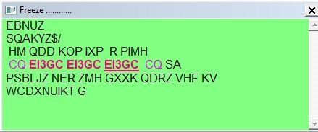

GR_7